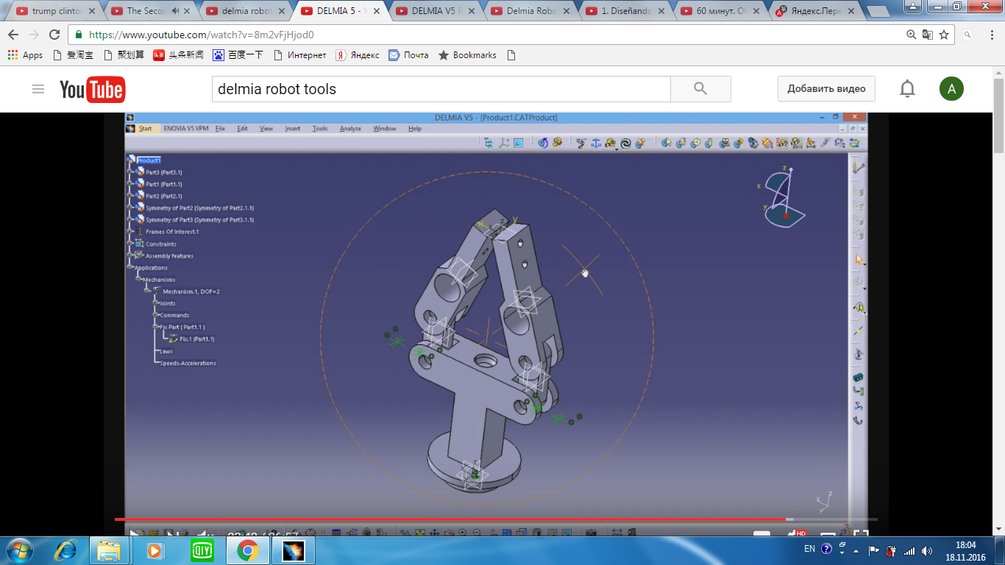
https://www.youtube.com/watch?v=8m2vFjHjod0

